**[IS113] Extra Exercises - Week 3 - Basic PHP**

**Resource Download**

* To download the **resource files**, go to: <https://bit.ly/2UtOfCz>
* You will see TWO (2) folders (**veg**, **php**).
  + Download & place the folders inside **<web root>/is113/extra3/** on your local computer.
  + You should be able to see the following directory/file structure on your local computer:

o **<web root>/is113/extra3/**:

* php/ (folder)
  + practice.php (file)
* veg/ (folder)
  + img/ (folder)
  + index.php (file)
  + process.php (file)

**NOTE:** If you spot any mistakes/errors in the questions, please contact Kyong at [kjshim@smu.edu.sg](mailto:kjshim@smu.edu.sg).

**Question 1 - PHP**

Go to **<web root>/is113/extra3/php/.** Complete the following **Parts A, B** and **C** inside **practice.php** file.

**NOTE:** Please do not hard-code the names and the grades. You must retrieve it from the associative array.

**HINT**: You must use a loop in PHP.

**Part A (*)**

Given an associative array as shown below:

|  |
| --- |
| **$student_grades = [**  **'Kee Hock' => ['A+', 'A', 'B+', 'A-'],**  **'Debbie' => ['A', 'B+', 'A-', 'A'],**  **'Patrick' => ['B', 'C', 'F', 'B-']**  **];** |

Complete **Part A** in the **practice.php** file so that it displays the following HTML table.

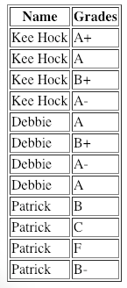

**Part B (*)**

Given the same associative array, complete **Part B** in the **practice.php** file so that the following HTML table is displayed. Please take note of the following:

* If the grade is **A+** or **A**, font color should be **blue** and font size should be **6**.
* If the grade is **A-**, font color should be **green** and font size should be **5**.
* Otherwise - for all other grades, font color should be **red** and font size should be **4**.

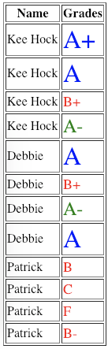

**Part C (**)**

Given the same associative array, complete **Part C** in the **practice.php** file so that it displays the following HTML table.

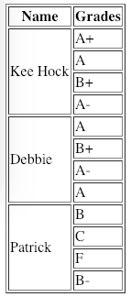

**Question 2 - Vegetables**

Go to **<web root>/is113/extra3/veg/**. It contains the following:

|  |  |
| --- | --- |
| **Item** | **Description** |
| **index.php** | 1. An associative array **$vegTypeArr** whose key is vegetable name and value is the type of vegetable, and  2. An incomplete form that will submit to **process.php**. |
| **process.php** | An associative array **$vegQtyArr** whose key is vegetable name & value is the quantity available. |
| Folder **img/** | Contains JPEG images of leafy vegetables: **cabbage.jpg**, **lettuce.jpg** and **spinach.jpg**. |

**Part A (*)**

1. Edit **index.php** to add a dropdown list of **leafy** vegetables

a. Get the vegetable names from the array **$vegTypeArr**.

b. Do NOT hardcode the vegetable names.

2. If done correctly, the form should look like this:

|  |
| --- |
|  |

**Part B (*)**

1. Edit **process.php** to

a. Variable **$veg** is the selected vegetable (submitted form value).

b. Obtain the quantity from **$vegAtyArr**

c. Display the image of the vegetable as many times as the quantity.

2. For example, if the selected vegetable is ‘spinach’, there are 2 spinaches, thus, the page should look like this.

